Designing and Creating Prototypes for users: Low-Fi Prototyping & Pilot Usability Testing

SIGNATURE BLOCK
Statement | I did my share of the work, and I have a general understanding of the contents of the assignment.
Team Member | Contribution | % of Total | Signature | Date
Alfred Acosta | - Sketches Worked on:  - Initial Gestural Interface  - Selected WebApp/Browser Extension Interface  - Selected Speech Interface  - Assisted with Presentation/Report | 33.33 | 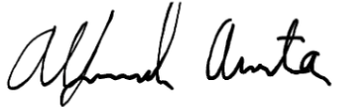 | 10/18/26
Javier Coyoc | - Sketches Worked on:  - Initial Speech Interface  - Initial Augmented Reality Interface  - Selected WebApp/Browser Extension Interface  - Selected Speech Interface  - Assisted with Presentation/Report | 33.33 | 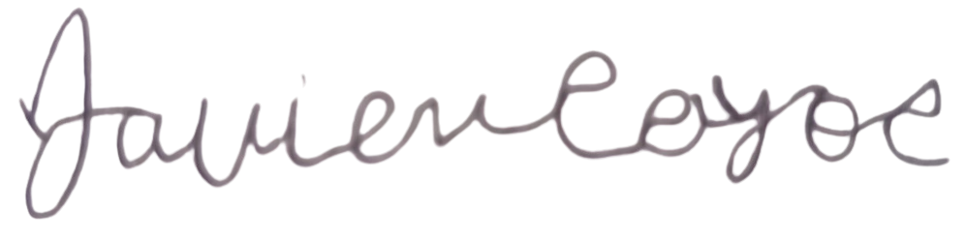 | 10/18/26
Ervin Lin | - Sketches Worked on:  - Initial Web App/Browser Extension Interface  - Initial Mobile App Interface  - Selected WebApp/Browser Extension Interface  - Selected Speech Interface  - Assisted with Presentation/Report | 33.33 | 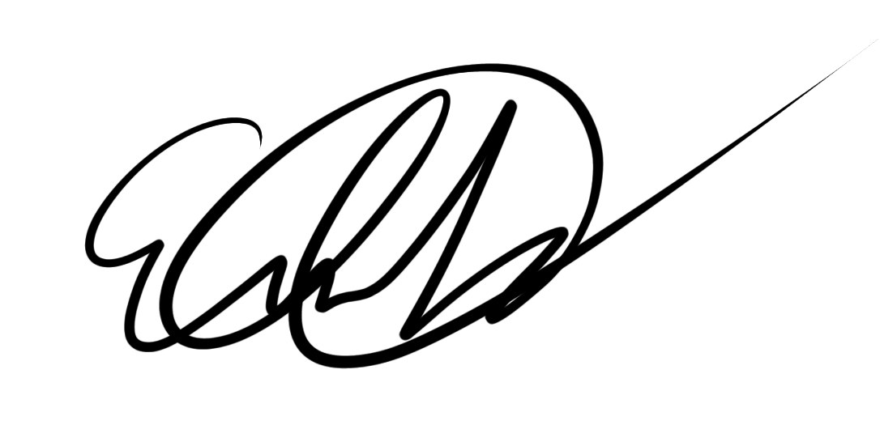 | 10/18/26

Table of Content

Table of Content 2
Introduction 3
Value Proposition 3
Mission Statement 3
Problem Statement/Solution 3
Sketches 4
Top two (2) Designs with Further Storyboarding 8
Web App/Extension Interface - Design 1 8
Speech Interface - Design 2 9
Selected Interface Design 10
Task 1: Use Reading View [Demo] 10
Task 2: Use Clean My Notes 11
Task 3: Teacher Preview 11
Rationale (Pros & Cons) 12
Prototype Description & Images 13
Method 16
Participants: demographics, how recruited/compensated 16
Environment 16
Tasks 17
Procedure 18
Test Measures 18
Team Member Roles 18
Results 19
Discussion 21
Appendices 23
Appendix A: Consent Form 23
Appendix B: Observation Sheet 25

Introduction

Value Proposition

Making web content readable for every mind

Mission Statement

To provide an accessible and easy-to-use UI for users with dyslexia and teachers who want to format text into a more dyslexia-friendly format

Problem Statement/Solution

Standard digital learning materials and web pages use dense layouts, harsh contrast, and rigid typography that cause rapid visual fatigue for dyslexic readers. ClearType is an interactive web platform that lets students and teachers preview, test, and toggle dyslexia-friendly formatting in real time through instant visual overlays and live controls.

Sketches

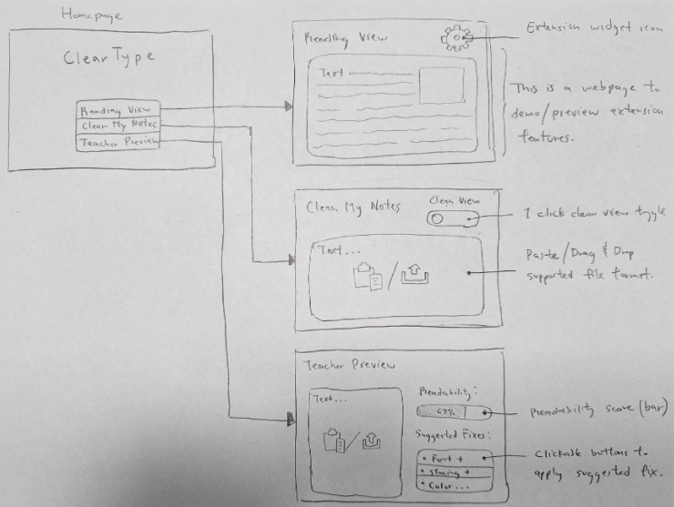
Figure 1: Web App/Browser Extension Sketch

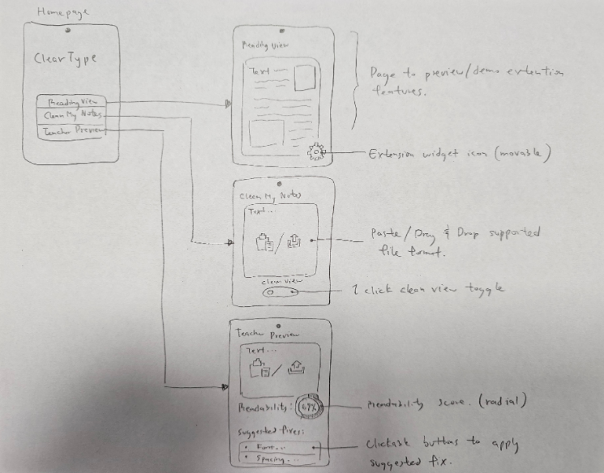
Figure 2: Mobile App Interface Sketch

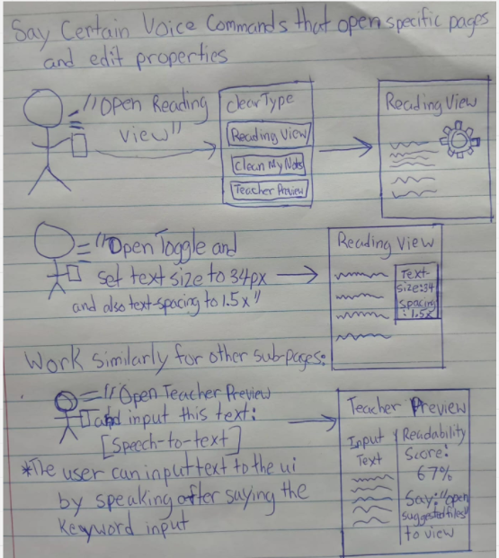
Figure 3: Speech Interface Sketch

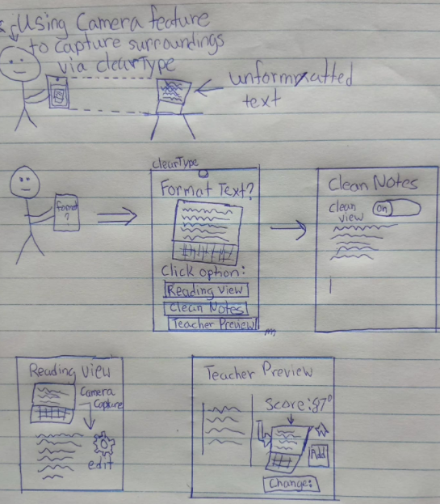
Figure 4: AR Interface Sketch
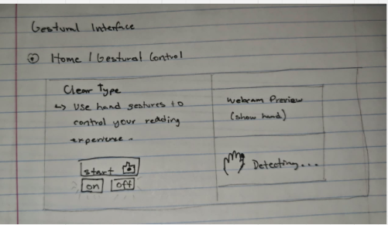
Figure 5: Gestural Interface Sketch (1 of 3)

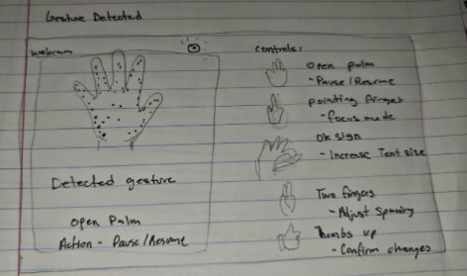
Figure 6: Gestural Interface Sketch (2 of 3)

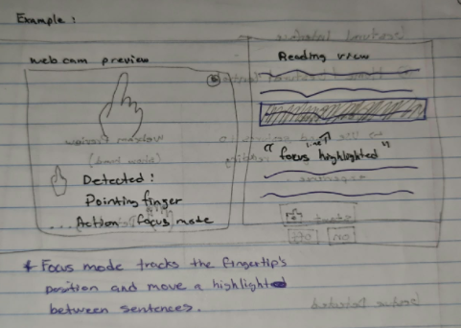
Figure 7: Gestural Interface Sketch (3 of 3)

Top two (2) Designs with Further Storyboarding

Web App/Extension Interface - Design 1

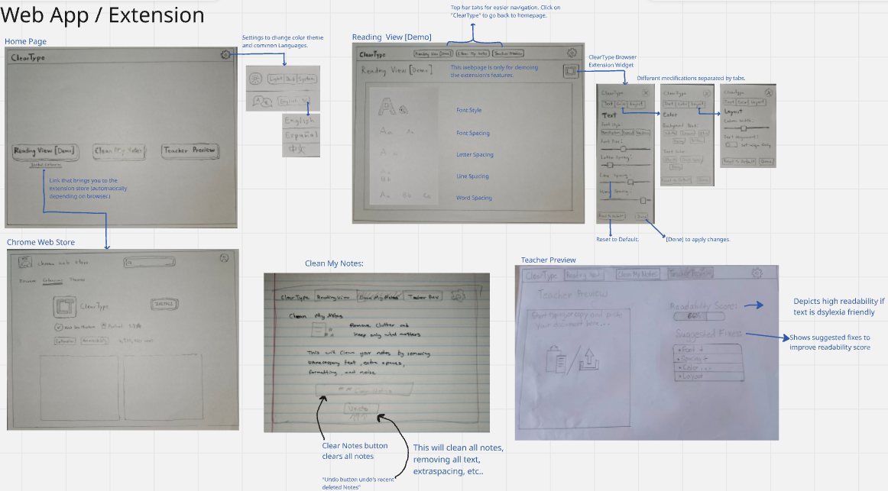
Figure 8: Web App/Extension Interface with further storyboarding

The Web App/Extension interface uses the familiar web interface that most users accustomed to websites are familiar with. This interface is unique as well, as it includes an extension which users can use outside of the website. For example, if they are viewing a document and want to make the text more dyslexia-friendly, they can do so using the extension.

Speech Interface - Design 2

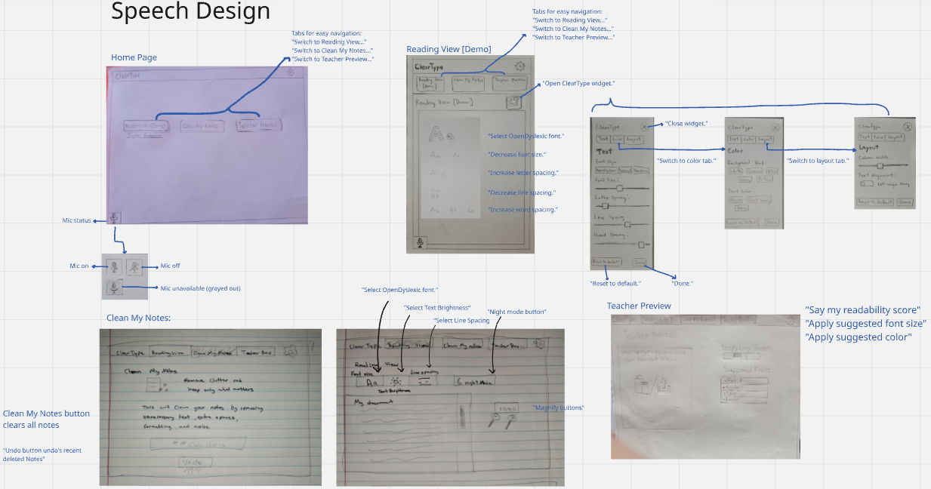
Figure 9: Speech Interface with further storyboarding

The speech interface allows users to use certain speech commands to interact and navigate the interface. While this concept allows for better interactivity and some users may prefer this, it is very tedious to implement.

Selected Interface Design

Selected Interface: Web App/Extension

Task 1: Use Reading View [Demo]

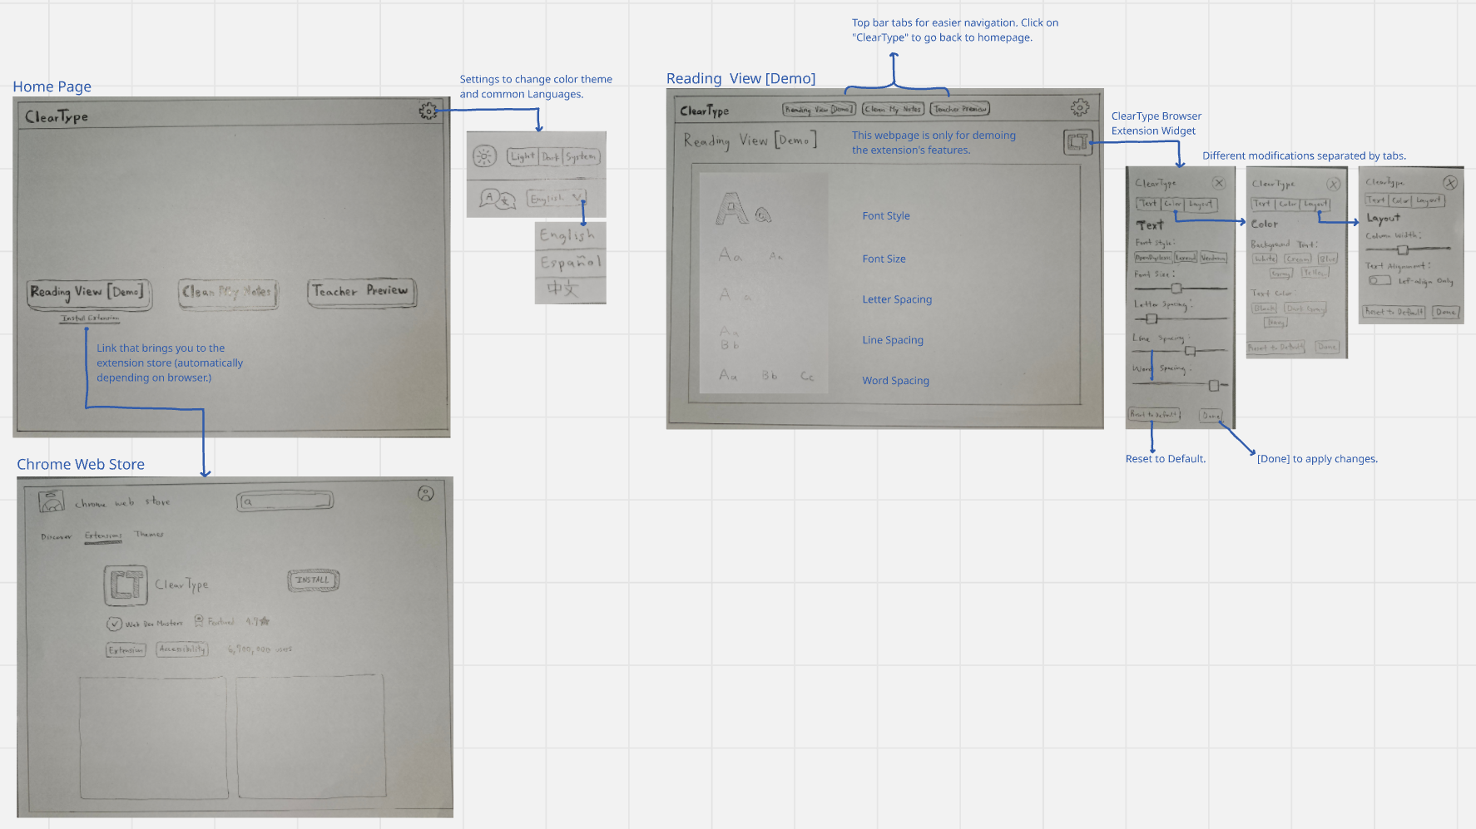
Figure 10: Web app/Extension - Task 1: Use Reading View

A user will:
- Change color mode/language
- Install ClearType Browser extension (automatically brings the user to the right store).
- Enter Reading view [Demo]
- Change:
- Font style
- Font size
- Letter spacing
- Line spacing
- Word spacing
- Other extension features can be accessed via navigation tabs.

Task 2: Use Clean My Notes

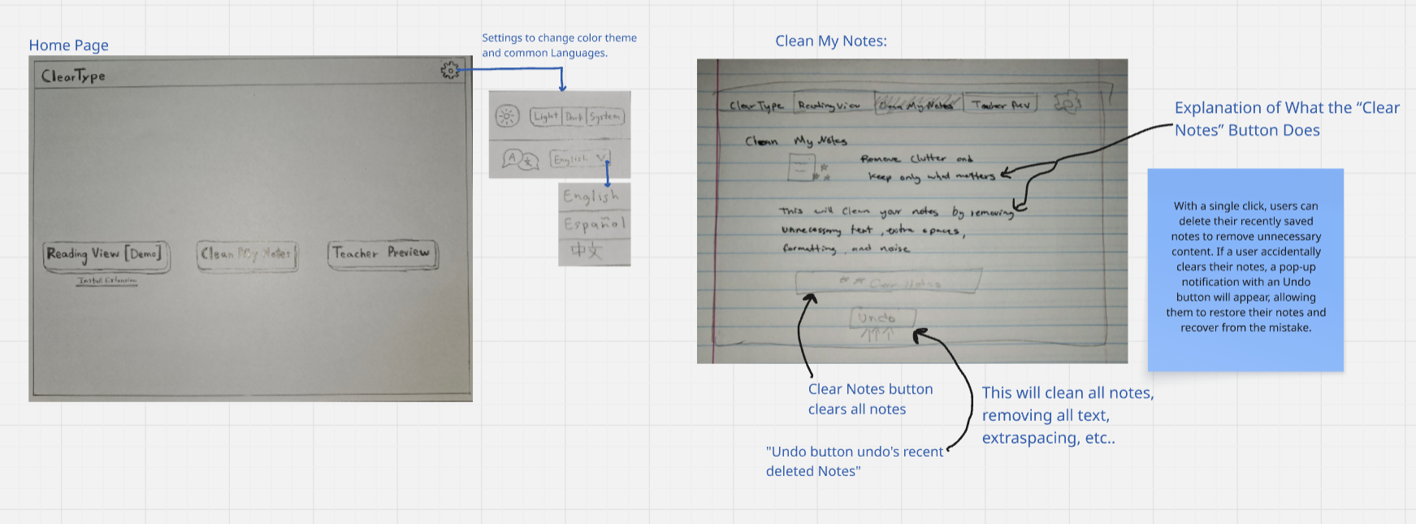
Figure 11: Web app/Extension - Task 2: Use Clean My Notes

A user will:
- Want to delete recent notes
- By clicking on “Clear Notes”
- It instantly deletes the notes
- All font spaces, styles, size, etc.
- If the user accidentally deletes a recently saved
- note, an Undo button will appear, allowing the
- student to restore the deleted note.

Task 3: Teacher Preview

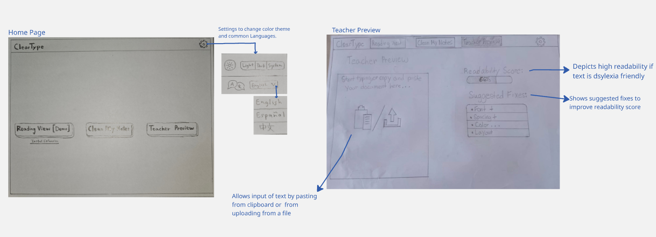
Figure 12: Web app/Extension - Task 2: Use Teacher Preview

User will be able to:
- Change the color theme & language
- Enter Teacher Preview
- Will enter text using either one of the input methods
- Check their readability score when the text is entered
- See & Apply suggested fixes (Font, Spacing & Color)

Rationale (Pros & Cons)

The main reason for choosing a combined web app and browser extension interface for ClearType is to meet users where they’re at by balancing analysis with contextual use.

The ClearType Browser Extension Widget is essential. The main value of ClearType (changing text, line spacing, and color) is that it is a tool users with dyslexia may need when browsing news sites, articles, and documentation. By choosing an extension interface, the design lets ClearType tools overlay any webpage. ClearType users can change their reading context without leaving the page, making it very accessible.

Pros | Cons
Accommodates both passive readers needing quick web adjustments and educators needing full document analysis | Requires context switching when users must manually copy-paste or upload documents to analyze them
Enables real-time text, font, letter, line, and word spacing adjustments directly over external websites | Browser security policies or external site CSS may occasionally interfere with extension overrides

Prototype Description & Images

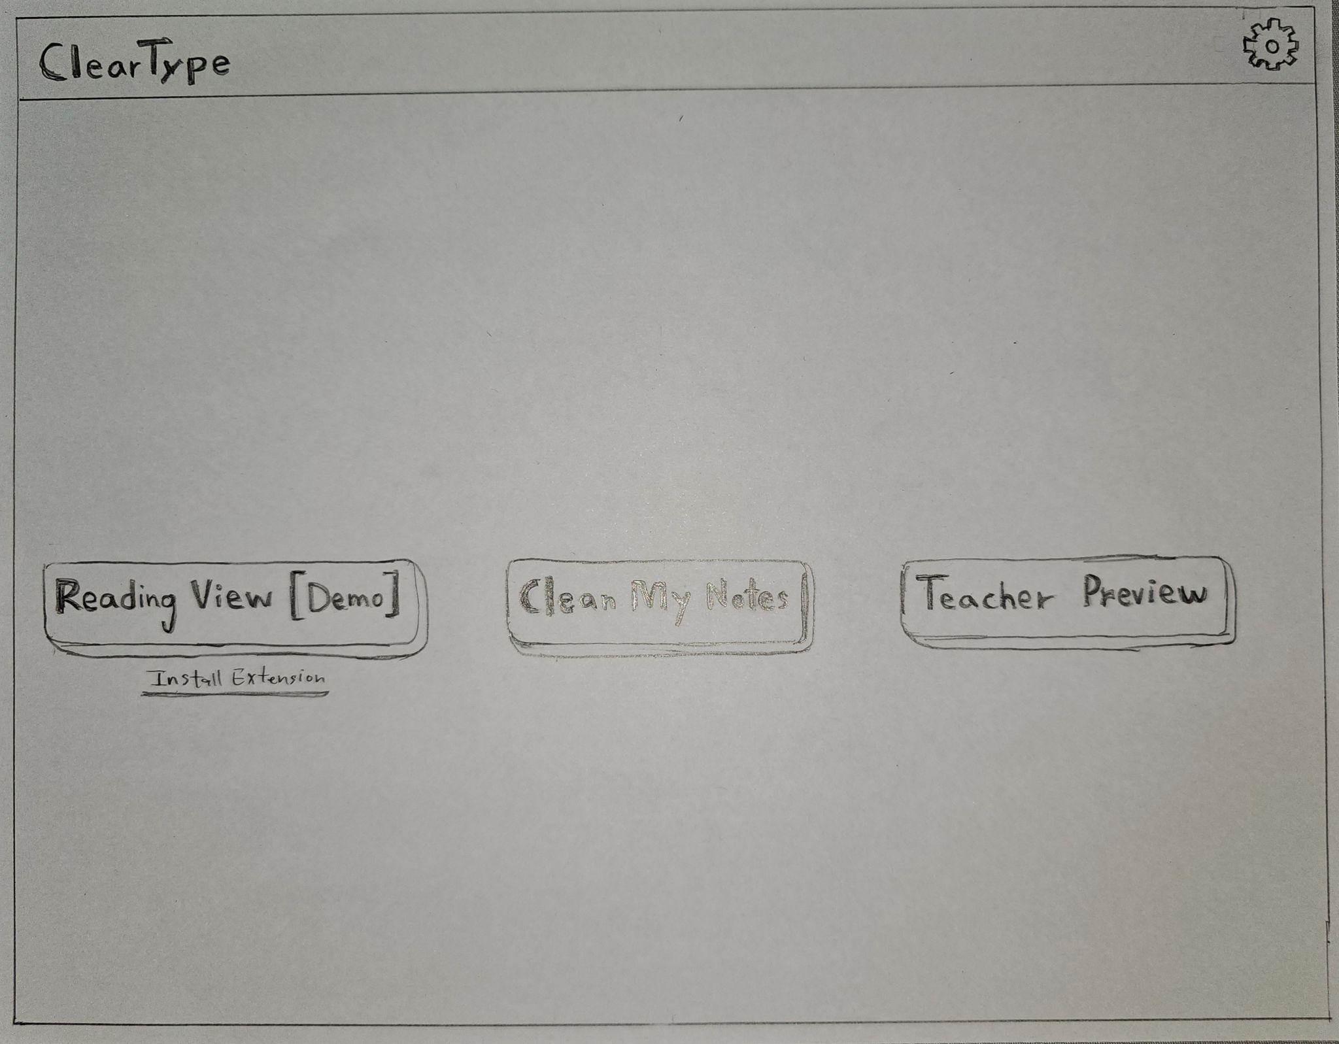
Figure 13: ClearType HomePage

Button-on dashboard | Description-of-function | Screen-for-that function
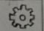 | Opens settings which allows you to change the theme of the system to dark or change the language | 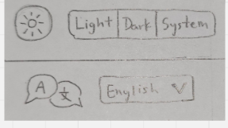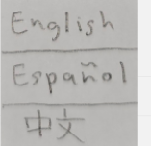
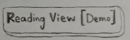  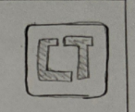 | Opens Reading View page, which allows users to test ClearType extension slider properties that change the example text.  Located in the top-right of Reading View, is the ClearType button that opens a pop-up widget with slider properties. The user can select which property type and change the sliders to change the text. | 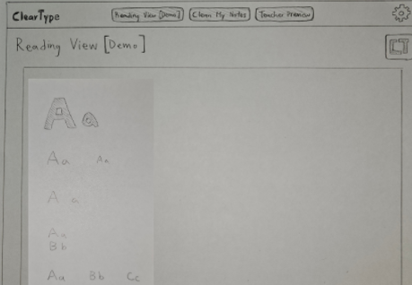  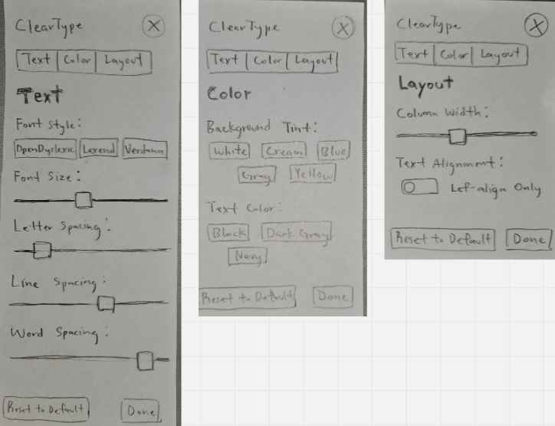
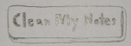 | Opens Clean My Notes, which allows user to input text and de-clutter it and make it more readable | 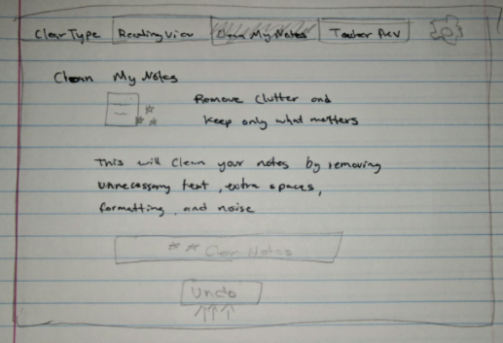
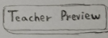 | Opens Teacher Preview page, that allows teachers to input their text and check if it is readable for those with dyslexia. It also provides suggestions to improve text | 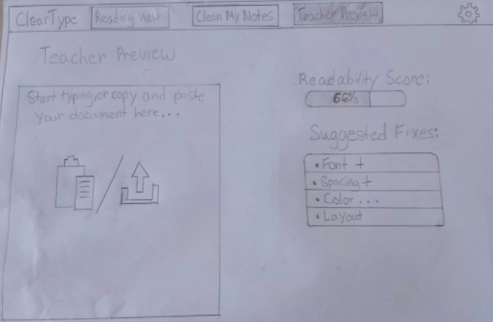
 | A link that when clicked takes user to ClearType extension in Chrome Web Store | 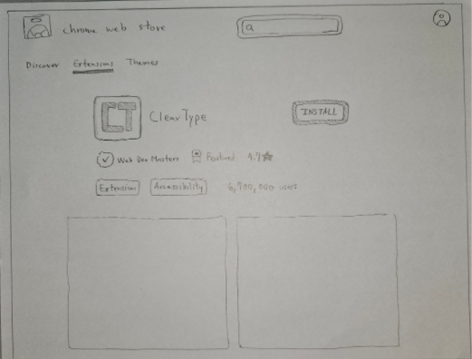

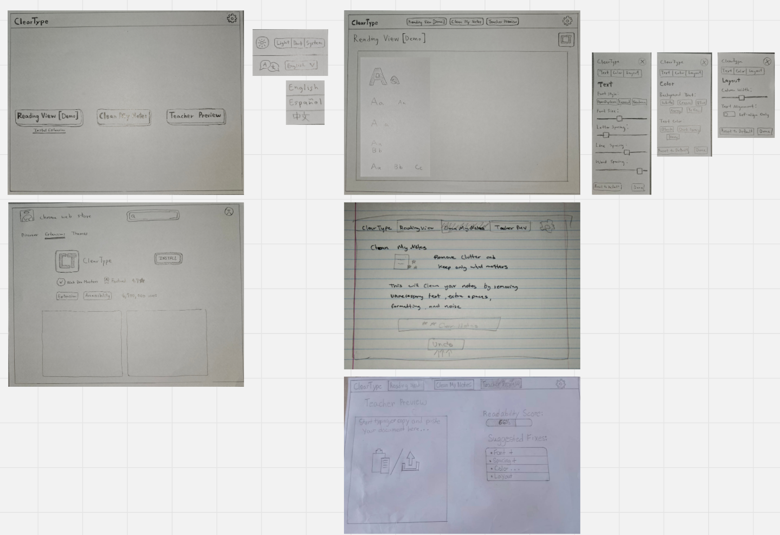
Figure 14: ClearType - Entire System using Web App/Extension Interface

Method

Participants: demographics, how recruited/compensated

The pilot usability testing involved three participants: two teachers and one student with dyslexia. The participants were selected to represent the intended users of ClearType, which is designed to support students who experience reading difficulties and teachers who prepare educational materials. Including both teachers and a student allowed the team to examine the interface from the perspectives of content creators and readers.

Environment
Testing took place in each participant’s own familiar setting to reduce discomfort and keep their attention on the prototype rather than an unfamiliar location. All participants were tested at their own desks, using their personal desktop or laptop computer as the surface for navigating the paper screens, with printed task cards provided separately. In each session, the facilitator placed the relevant paper prototype screens within reach of the participant and swapped them in as the “computer” role in response to the participant’s actions, while the observer took notes nearby. No additional equipment beyond the paper prototype, task cards, and the participant’s own device (used only as a stable surface, not as part of the interface) was required.
Provided Images:
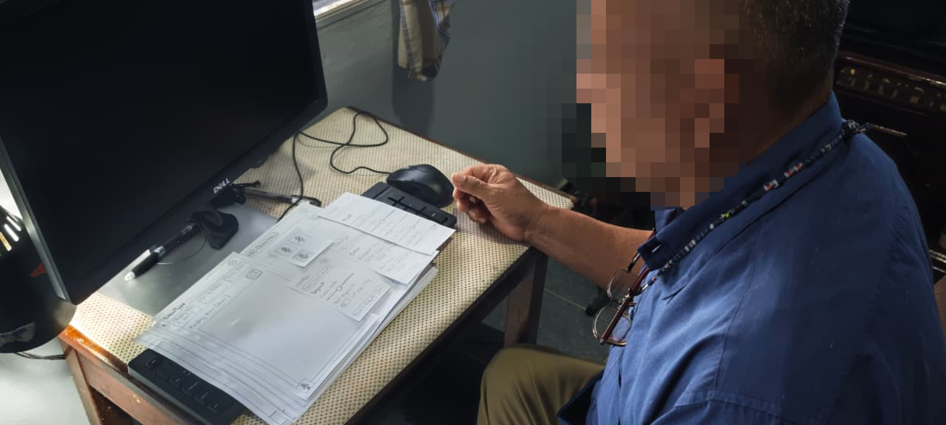

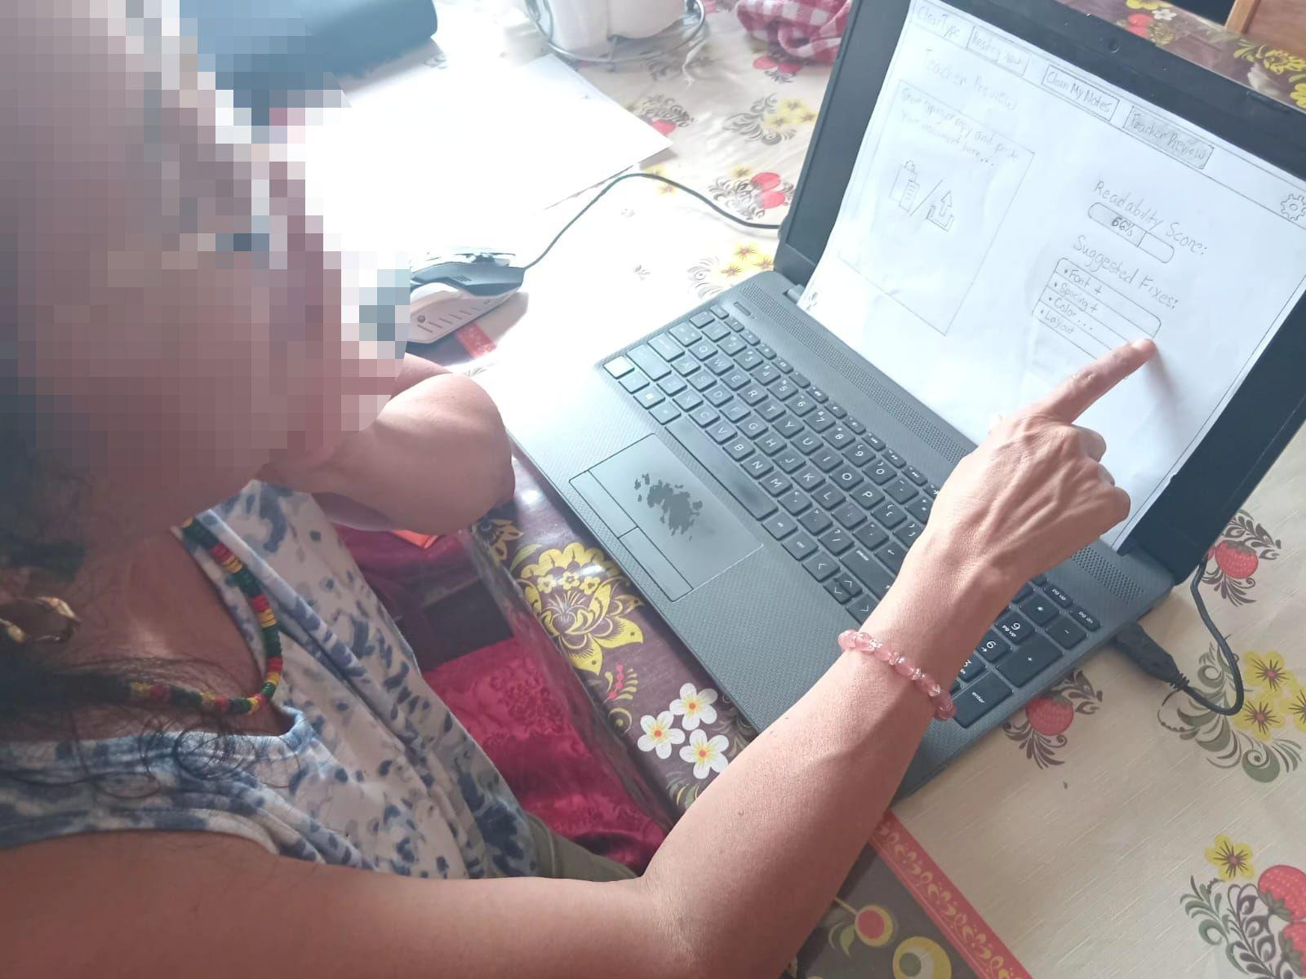

Tasks

Participants were asked to interact with the ClearType low-fidelity prototype and complete tasks representing its main functions. The tasks were designed to evaluate whether users could navigate the interface, locate important features, and understand how the proposed tools would support reading and text preparation.
The following tasks were included in the pilot usability test:
- Use Reading View: Navigate to Reading View and identify how to adjust font style, font size, letter spacing, line spacing, word spacing, and color settings.
- Use Clean My Notes: Locate Clean My Notes, enter or identify text that needs formatting improvements, and determine how the tool could make the text easier to read. Identify the Clear Notes and Undo functions.
- Use Teacher Preview: Navigate to Teacher Preview, identify how to enter text, locate the readability score, and determine how to view and apply the suggested improvements.
- Navigate the interface: Locate the settings, identify the language and theme options, and find the link to the ClearType browser extension.
These tasks represented the principal features of ClearType and allowed the team to examine the clarity of its navigation, labels, controls, and overall interface structure.

Procedure

The usability testing was conducted as a pilot evaluation of the ClearType prototype. Each participant was introduced to the purpose of the project and given an opportunity to interact with the proposed interface. Participants were asked to complete the assigned tasks while the team observed their interactions.
During the sessions, the team focused on whether participants could locate the appropriate pages, understand the purpose of each feature, and identify the controls needed to complete a task. The team also noted any confusion, navigation difficulties, questions, and suggestions raised during the sessions.
After completing the tasks, participants were asked to provide feedback on the interface, including its ease of use, clarity, usefulness, and possible improvements. The observations and feedback were intended to help the team identify usability issues before developing a more refined version of ClearType.

Test Measures

The following measures were used or proposed to evaluate the usability of the prototype:
- Task completion: Whether participants could complete each assigned task independently, with assistance, or not at all.
- Navigation and discoverability: Whether participants could locate the relevant pages, buttons, and controls.
- Ease of use: How easily participants understood and interacted with the interface.
- Errors and difficulties: Any incorrect selections, confusion, or problems encountered during the tasks.
- Participant feedback: Participants' opinions about the layout, readability controls, navigation, and usefulness of the proposed features.
- Suggested improvements: Recommendations for making ClearType more accessible and easier to use.

Team Member Roles

- Facilitator: Alfred Acosta
- Computer: Ervin Lin
- Observer: Javier Coyoc

Results

Overview of Experimental Results
The pilot usability test produced observations from three participants who interacted with the ClearType prototype. The results revealed that participants were able to identify and use several of the proposed features, while certain aspects of the interface required additional clarification or redesign.
The main issues concerned the visibility of the browser extension link, the usefulness of the Undo function, the presentation of suggested fixes in Teacher Preview, and the organization of the reading customization controls.

Participant 1 (P1)
P1 completed the simpler tasks quickly and demonstrated that the basic functions of the prototype could be understood without substantial difficulty. During the Teacher Preview task, P1 was able to locate the Suggested Fixes feature and apply formatting changes intended to improve the readability score.
P1’s experience highlighted the potential usefulness of providing teachers with actionable recommendations rather than requiring them to identify every formatting adjustment manually. The Suggested Fixes feature offers a convenient way to explore improvements to educational materials.
However, P1 recommended adding a live score-impact preview beside each suggested fix. This would allow users to see how much a proposed change might improve the readability score before deciding to apply it.
This recommendation identifies an opportunity to make Teacher Preview more informative and transparent. Showing the potential impact of each adjustment could help teachers compare available options and make more informed decisions when formatting their learning materials.

Participant 2 (P2)
P2 encountered difficulty locating the browser extension link on the homepage. Although the link was present, P2 initially interpreted the raw text as ordinary text rather than a clickable link. As a result, P2 assumed that they needed to search for ClearType manually in the Chrome Web Store.
Once P2 passed this initial obstacle, they continued using the prototype. This experience demonstrated that the presence of a feature does not necessarily mean that users will recognize how to access it. Interactive elements must be visually distinguishable and clearly communicate their purpose.
P2 also appreciated the Undo safety feature in Clean My Notes after accidentally double-clicking the control to clear their notes. This observation highlighted the importance of providing users with a way to recover from unintended actions.
The findings suggest two design considerations. First, the browser extension link should be made more noticeable and its purpose should be clearly explained. Second, the Undo function should remain a prominent part of Clean My Notes because it can reduce the consequences of accidental deletion and give users greater confidence when interacting with the interface.

Participant 3 (P3)
P3 completed the note-cleaning and Teacher Preview tasks with ease. However, P3 found the browser extension widget confusing when attempting to toggle Reading View settings.
The primary difficulty was the vertical arrangement of the customization sliders. Font size, letter spacing, line spacing, and word spacing were stacked vertically, making it difficult to locate specific settings quickly. The number of controls presented together made the widget feel overwhelming.
This observation suggests that the extension widget may benefit from a more organized layout. Although offering multiple customization options supports personalization, displaying every control simultaneously may make the interface more difficult to navigate.
P3’s feedback supports the use of collapsible categories or predefined formatting presets. For example, users could select a Compact or Spacious preset before making further adjustments. Alternatively, settings could be grouped under headings such as Font, Spacing, and Color.
Such changes could reduce visual clutter and help users locate the controls they need without removing the flexibility that makes ClearType useful.

Discussion

The purpose of the pilot usability testing was to examine whether the proposed ClearType interface was understandable and suitable for its intended users. By involving two teachers and one student with dyslexia, the evaluation considered both the educational content preparation process and the reading experience.
The final interpretation should connect the recorded observations to the main objectives of ClearType. In particular, the team should determine whether participants could identify and understand the Reading View controls, locate Clean My Notes, and recognize how Teacher Preview could help teachers evaluate and format learning materials.
If participants completed the tasks without difficulty, this may indicate that the relevant navigation and controls were sufficiently clear for those participants. If participants required assistance or misunderstood particular features, those observations would indicate where the interface may need improvement. These conclusions should only be included when supported by the actual testing results.
The testing should also consider whether the interface communicates the purpose of its features clearly. For example, users should be able to distinguish between changing the appearance of text for personal reading and preparing educational materials for students. Clear labels, consistent navigation, and recognizable controls may help users understand these differences.
Accessibility is central to ClearType's value proposition. The prototype proposes customizable font styles, text sizes, letter spacing, line spacing, word spacing, and color themes to give users greater control over their reading environment.
The testing should examine whether these options are easy to find and understand. It should also consider whether users can identify the effect of each setting and return to a preferred configuration. Since reading preferences vary, the design should avoid assuming that one font, color combination, or spacing configuration will work equally well for every person with dyslexia.
Teacher Preview also has potential value for educators because it proposes a way to review text and identify possible formatting improvements. However, any readability score or automated suggestion should be presented as guidance rather than a definitive measure of accessibility. The effectiveness of such recommendations would require further evaluation.

Participant | Main Observation | Suggested Improvement
P1 | Successfully used Suggested Fixes but wanted to preview their effect on the readability score. | Add a live score-impact preview beside each suggested fix.
P2 | Did not recognize the extension link as clickable and initially thought manual searching was necessary. | Add a more noticeable installation link, a one-click installation option where supported, or a step-by-step guide.
P2 | Accidentally double-clicked clear Notes and appreciated the Undo function. | Retain and clearly present the Undo safety feature.
P3 | Found the vertically stacked extension sliders overwhelming and confusing to navigate. | Group controls into collapsible categories or introduce formatting presets.

Appendices

Appendix A: Consent Form

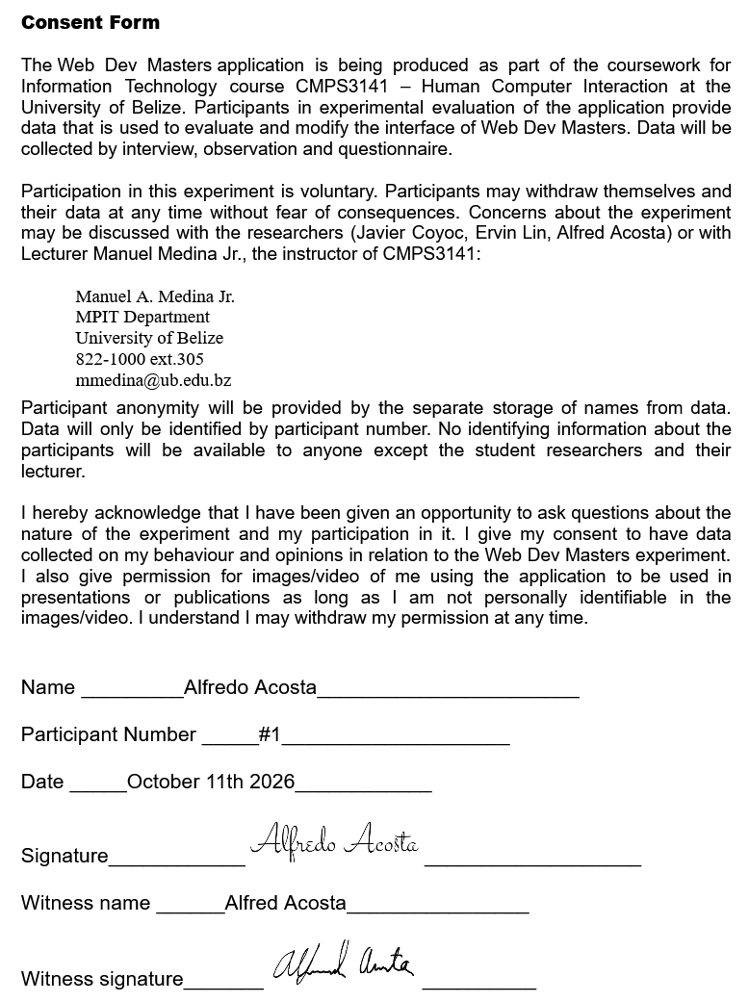
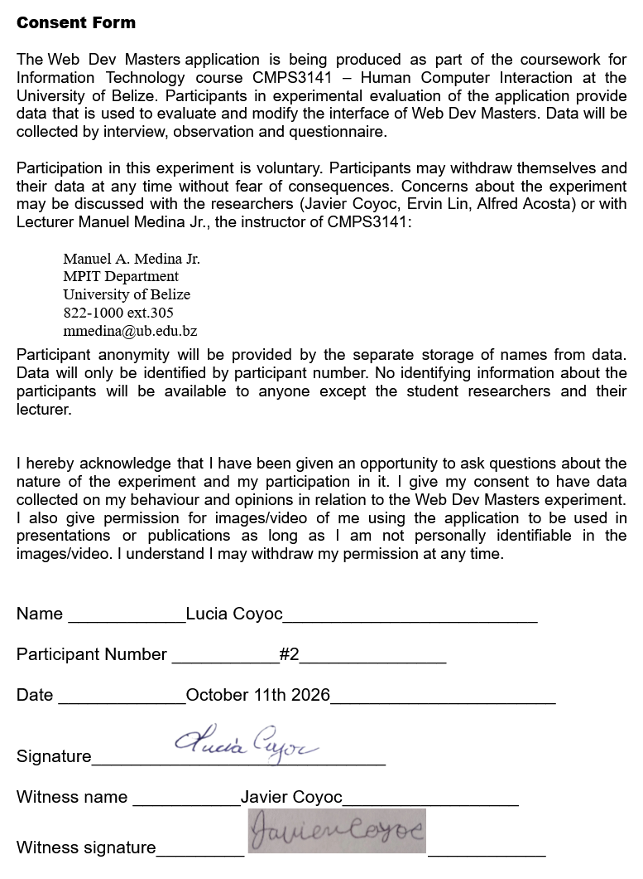

Appendix B: Observation Sheet

Participant ID | Task Name | Task Difficulty | Errors / Misclicks | Completion Time (sec) | Severity Rating
P1 | Task 1: Reading View Customization | Simple | 0 | 48 | 0
P1 | Task 2: Clean My Notes | Moderate | 0 | 22 | 0
P1 | Task 3: Teacher Preview | Complex | 1 | 95 | 1
P2 | Task 1: Reading View Customization | Simple | 2 | 65 | 2
P2 | Task 2: Clean My Notes | Moderate | 1 | 35 | 1
P2 | Task 3: Teacher Preview | Complex | 0 | 75 | 0
P3 | Task 1: Reading View Customization | Simple | 1 | 42 | 1
P3 | Task 2: Clean My Notes | Moderate | 0 | 18 | 0
P3 | Task 3: Teacher Preview | Complex | 0 | 60 | 0

